**Year 12**

**ATAR**

**Human Biology**

|  |
| --- |
| Name:  ANSWERS |
| Teacher: |

|  |  |  |  |  |
| --- | --- | --- | --- | --- |
| **Task 8: Mutations and Gene Pools Test** | | | | Weighting 5% |
|  | Marks Received | Marks Available | Percentage | |
| Multiple Choice |  | 10 |  | |
| Short Answer |  | 25 |  | |
| Extended Answer |  | 20 |  | |
| Total |  | 55 |  | |

Time Allocated:

Reading time: 5 minutes

Working time: 55 minutes

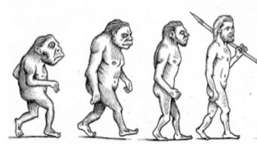

**Year 12**

**ATAR**

**Human Biology**

**MULTIPLE CHOICE ANSWER SHEET**

|  |
| --- |
| Name: |
| Teacher: |

For each question, shade the box to indicate your answer. Use only a blue or black pen to shade the boxes. If you make a mistake, place a cross through that square then shade your new answer. Do not erase or use correction fluid/tape. Marks will not be deducted for incorrect answers. No marks will be given if more than one answer is completed for any question.

|  |  |  |  |  |
| --- | --- | --- | --- | --- |
| **1** | a | b | c | d |
| **2** | a | b | c | d |
| **3** | a | b | c | d |
| **4** | a | b | c | d |
| **5** | a | b | c | d |
| **6** | a | b | c | d |
| **7** | a | b | c | d |
| **8** | a | b | c | d |
| **9** | a | b | c | d |
| **10** | a | b | c | d |

**PART A: Multiple Choice Section [Total: 13 marks]**

1. A gene pool is

(a) all the different genes found in an ecosystem.

(b) all the different alleles in an interbreeding population.

(c) the alleles in a group of individuals that cause a genetic disease.

(d) the total number of genes found in a species.

Question 2 refers to the Karyotype below.

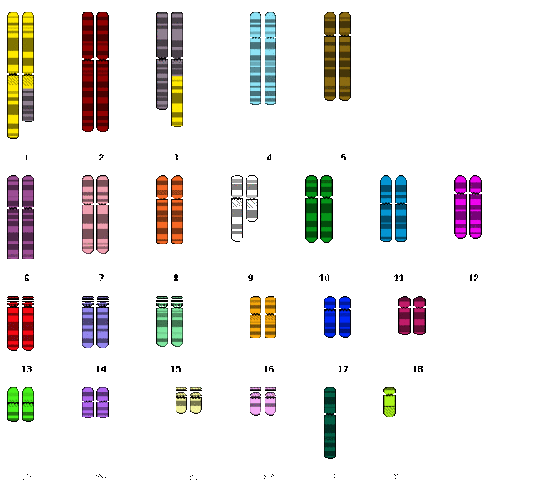

2. What are the two types of chromosomal mutations seen in the Karyotype above?  
(a) Translocation; Addition  
(b) Duplication; Inversion  
(c) Translocation; Deletion  
(d) Duplication; Non-disjunction

3. In the relatively isolated region of Lake Maracaibo in northwest Venezuela, there is an unusually high incidence of the genetically-inherited nerve disorder known as Huntington’s disease. Around the world Huntington’s disease is estimated to affect 5–7 people in 100 000. In Lake Maracaibo, it occurs at a rate of 700 people in 100 000. All of the individuals in Lake Maracaibo who carry the allele for Huntington’s disease can trace their ancestry to one of the original 19th century inhabitants of the region.

This example is an illustration of

(a) natural selection.

(b) the founder effect.

(c) a high rate of new mutations occurring.

(d) a natural disaster causing genetic drift.

4. The genetic disease known as Tay-Sachs has been the subject of much scientific debate over the evolutionary mechanisms that have produced the patterns of inheritance of the disease. Different theories, all of which have sound scientific reasoning, have linked Tay-Sachs to the founder effect, genetic drift and natural selection.

Which of the following would be the best reasoning to link the inheritance of Tay-Sachs to genetic drift?

(a) The original populations carried a high incidence of the allele.

(b) Affected populations tend to be small and reproductively isolated.

(c) Sufferers of the disease reproduce at greater rates than non-sufferers.

(d) Carriers of the allele have a survival advantage over non-carriers.

5. For Natural Selection to occur, mutations must be

(a) germline.  
(b) morphologic.  
(c) somatic.  
(d) autonomic.

Questions 6 and 7 refer to the information and diagram shown below.

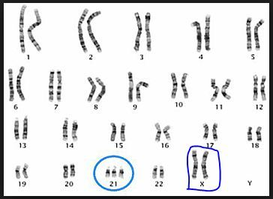

Down syndrome is an example of a disorder caused by a mutation. This is known as trisomy-21 and is shown below in the karyotype of an affected female.

6. This type of mutation is a

(a) point mutation.

(b) somatic mutation.

(c) chromosomal mutation.

(d) gene mutation.

7. The cause of this mutation is

(a) non-disjunction.

(b) deletion.

(c) duplication.

(d) translocation.

Question 8 refers to the diagram below.

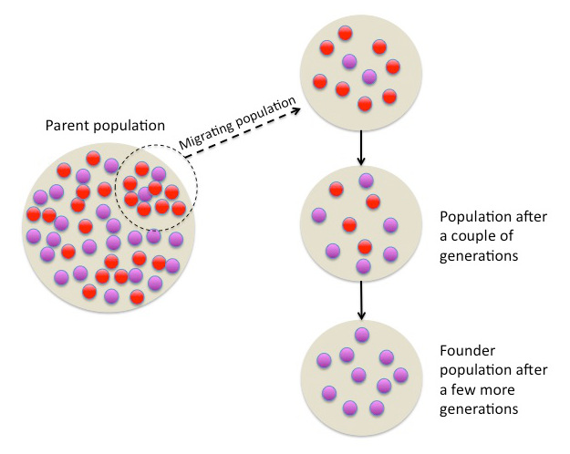

8. The diagram above is best representative of

(a) random genetic drift.  
(b) the Founder effect.  
(c) migration.  
(d) natural selection.

9. Which of the following statements is NOT correct?

(a) Heterozygous individuals with one Tay-Sachs allele appear to have increased resistance to tuberculosis.  
(b) Heterozygous individuals with one sickle-cell anaemia allele have a survival advantage in areas where malaria is prevalent.  
(c) Thalassaemia is an autosomal recessive disease in which anaemia results from the formation of distorted red blood cells.  
(d) Cystic fibrosis is an autosomal recessive disease caused by a mutation preventing the gene from producing a protein that will be able to function in the body.

10. The Amish population of Eastern Pennsylvania started as a small number of German immigrants, about 200 individuals. The Amish carry an unusually high frequency of a number of inherited disorders, such as dwarfism (Ellis-van Creveld syndrome), polydactyly (extra fingers or toes), abnormalities of the nails and teeth, and in about half of the individuals, a hole between the two upper chambers of the heart. The most likely explanation for the Amish population to experience high frequency of these disorders is

(a) gene flow  
(b) geographical isolation.  
(c) natural selection.  
(d) genetic drift

**PART B: Short Answer Section [Total 25 marks]**

**Question 11 [10 marks]**

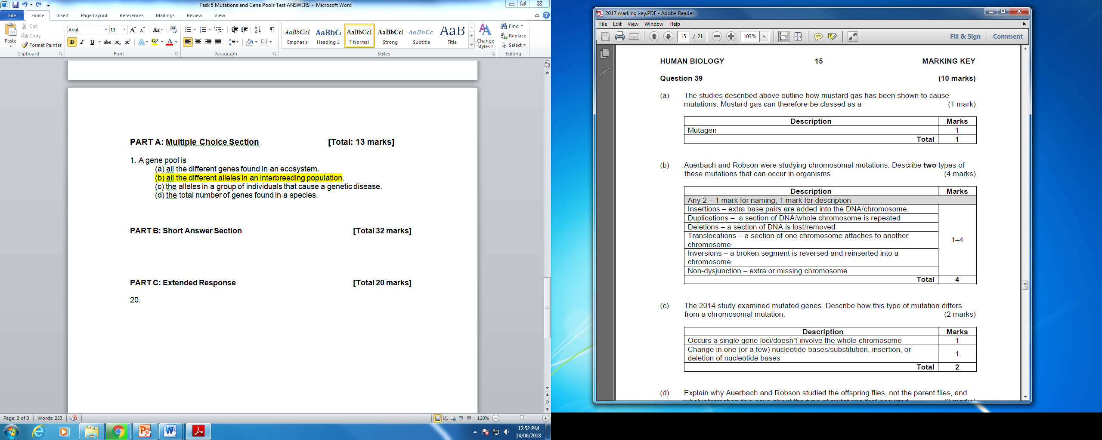

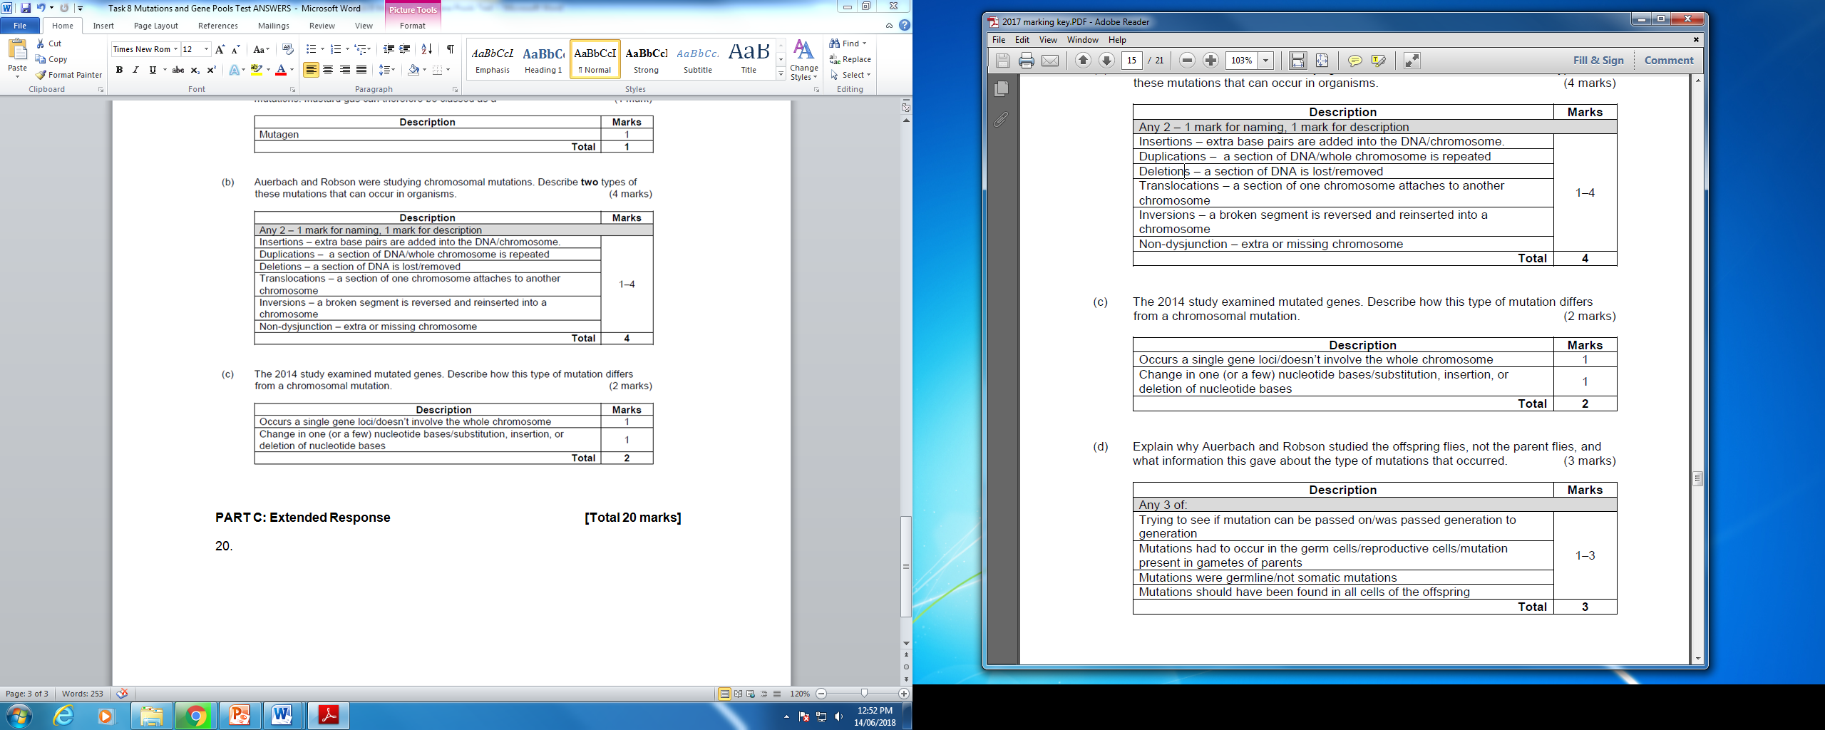

**Question 12 [2 marks]**

West Nile Virus (WNV) was first identified in 1937, and is known to lethally infect humans. Once confined to Europe, Asia, the Middle East and Africa, outbreaks are now occurring in Northern America and other Western countries. Studies have found that the protein CCR5(+) and its mutated form CCR5∆32, are associated with WNV susceptibility. The table below shows the distribution of genotypes in patients with and without WNV in Northern America.

|  |  |  |  |
| --- | --- | --- | --- |
| Genotype: | +/+ | +/∆32 | ∆32/∆32 |
| Patients with WNV | 321 | 78 | 18 |
| Patients without WNV | 155 | 16 | 2 |

Using the data above, the allelic frequency of **CCR5∆32** homozygotes was calculated and is stated below.

Patients with WNV: 0.04

Patients without WNV: 0.01

Given that the percentage of **CCR5∆32 homozygotes** in North America is usually 1 percent, compare the frequency of **CCR5∆32 homozygotes** in both populations. (2 marks)

**CCR5∆32 homozygotes are present at the normal frequency in population without WNV (1), but are nearly four times more common than usual in the West Nile patients (1)**

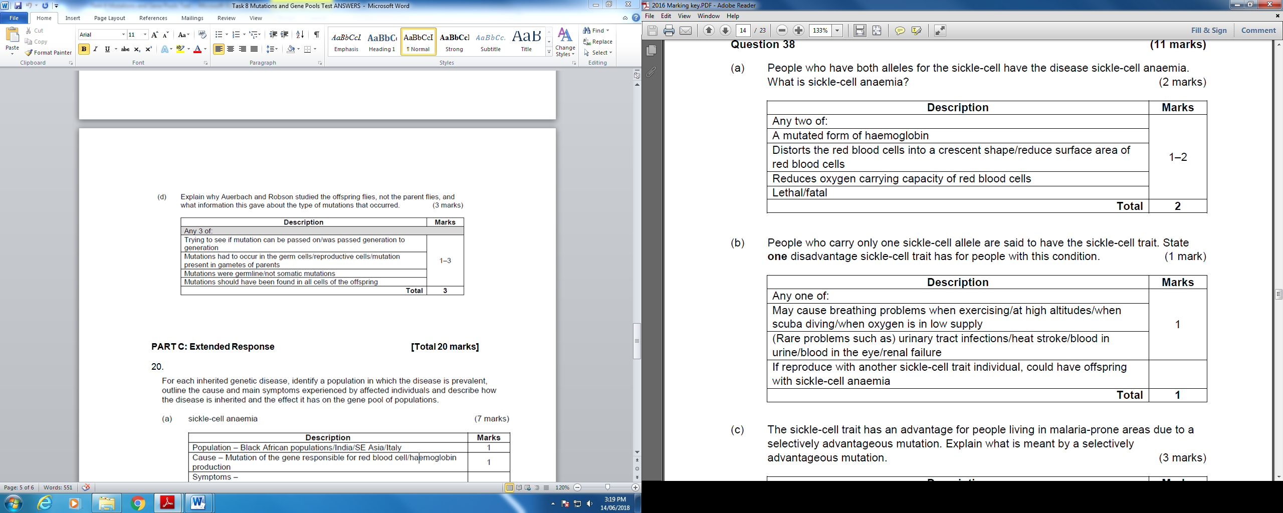

**Question 13 [7 marks]**

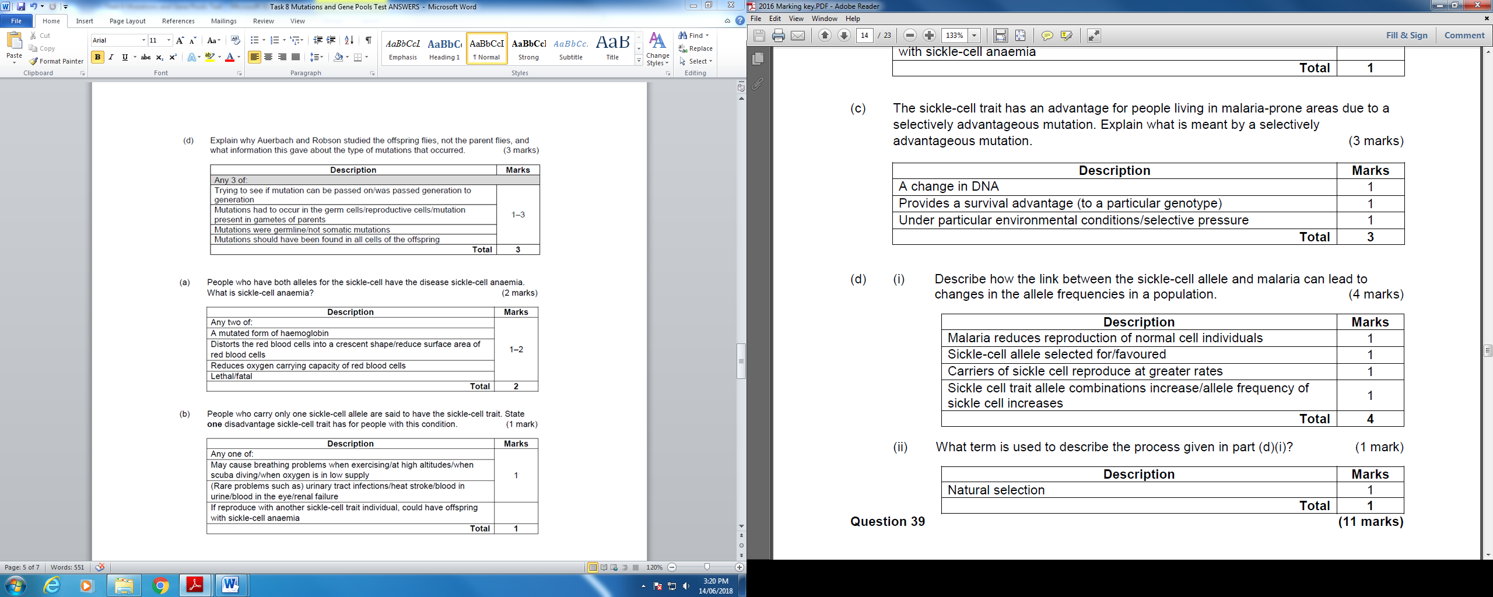

**Question 14 [6 marks]**

Using examples, explain how a lethal recessive mutation such as the Tay-Sachs disease can bring about changes in the gene pool through the following two evolutionary mechanisms:

1. genetic drift [3]
2. natural selection [3]

Genetic Drift [3]

* TS disease has higher occurrence in Ashkenazi Jews in Eastern Europe [1]
* As a fatal disease, its frequency worldwide is very low but is higher amongst the A Jews because the Jewish population tends to be small and isolated. [1]
* This small and isolated population increases the chance of genetic drift – random, non-directional variation (which explains why a rare allele becomes more frequent in small populations) .[1]

Natural Selection [3]

* While individuals with two normal alleles would be more susceptible to TB, and would possibly die due to TB while individuals with two TS alleles would die early in life. [1]
* Heterozygotes, on the other hand, would have increased resistance to TB and therefore have a survival advantage and would pass their alleles on to the next generation. [1]
* Over time, the gene pool would have more Tay Sachs alleles /frequency of TS allele increases. [1]

**PART C: Extended Response [Total 20 marks]**

15.

